Sestavi učni list za sošolce.
Read and draw
There is a blue vase on the cupboard.
There is a brown teddy bear on the bunk bed.
There are two red balls on the floor.
There are three purple books on the cupboard.
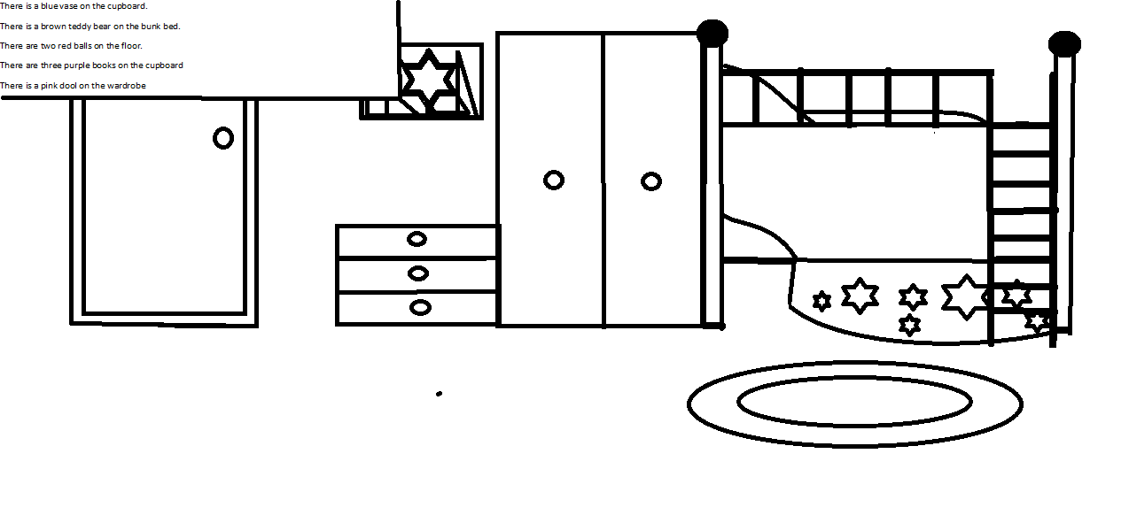
There is a pink doll on the wardrobe. Ela G.Č., 4.r.

